IBP2012-IVIS-003 Making the F1 Nursery Book

Introduction:

There are several ways the F1 list can be formed. This exercise will demonstrate making a planned series of crosses by matching parents from two lists, a female parent list and a male parent list.

Objectives:
At the end of this chapter, the user should be able to:

A. Making the F1 List
- Use the Crossing manager to specify a series of crosses betweem matched pairs of parents in two lists
- Specify a naming convention to give the crosses names in a series.
B. Making the F1 Nursery Book
- Create a study for population development nurseries
- Start the Nursery book wizard
- Open a nursery template
- Open a germplasm list
- Use the wizard to generate nursery book
- Export the Nursery book for data collection

A. Making The F1 List

Tutorial Steps:

- Run the Breeding Manager from the IB Workbench.

- Select Nursery Manager (m) from the tool bar located at the upper left corner of the application, then click the Cross radio button, and click ok (check symbol)

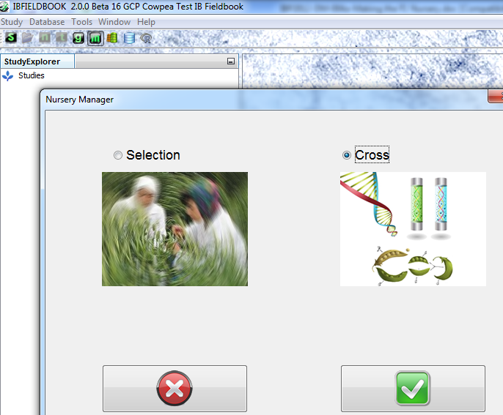

- Use the pull down arrow to select OTHER CROPS for naming Convention. Enter “UCR2010” in the Prefix box, “1” in the Start No. box, leave the Suffix box blank, but check the Include leading zeros chack box and set the Numeric Field Width to 3.
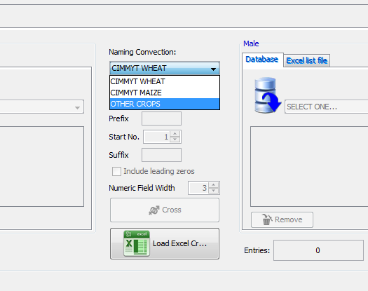

- Load the Female parent list by selecting list “UCR2010F” from the database pick list on the left, and the male parent list “UCR2010M” on the right. Then click the cross button.
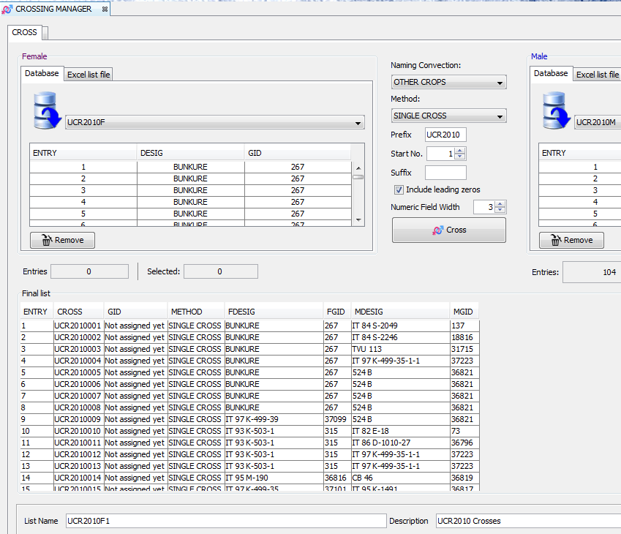

- A list of crosses between matched pairs is shown. Enter a list name “UCR2010F1” and a list description “UCR 2010 Crosses” in the text boxes at the bottom of the screen and click save to save the list of crosses. IF you select Germplasm for the Database menu you can see the new list UCR2010F1.

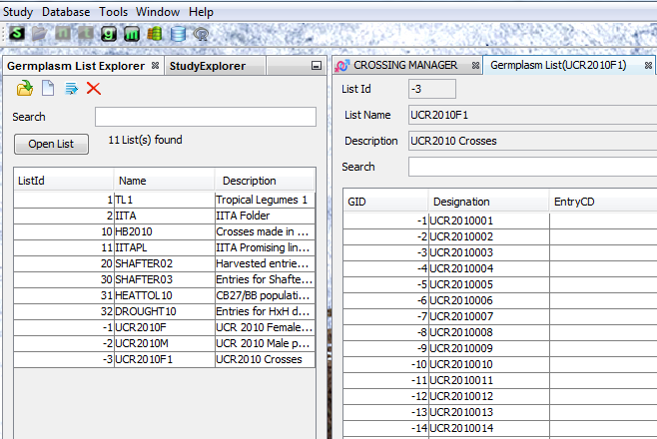

6. Close the Breeding manager Application.

B. Making the F1 Nursery Book

Tutorial Steps:

- Run the Breeding Manager from the IB Workbench

- Create a Study by selecting Study  New Study on the main menu located at the upper left corner of the form (or right-clicking the study header in the StudyExplorer).

Note: A 'study' is a unit of work within a project which generally has a specific objective such as '2011 multi-site evaluation of promising lines' and provides the structure to contain data sets relevant to that objective.

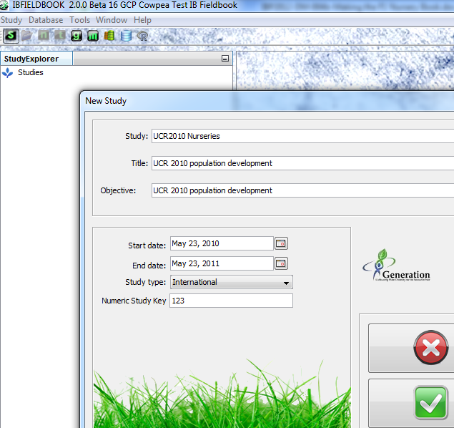

- Enter a study name, title, objective, start date and end date, select the study type and enter a study key. The name, title and objective are obligatory and you will be prompted to fill these fields. The optional study key is a numeric link to an institutional project management system if you have one.

Note: The study name should be a short name unique to the project and it is best to obtain agreement among project participants on a naming convention for studies.

In this example, type “UCR201 Nurseries” as Study, “UCR 2010 population development” as title, and objective.

Enter the start and end data by clicking the square button beside them. Select the month, date and year. In this example, enter “June 23rd 2010” as start date and “June 23rd 2011” as end date.

After filling all appropriate fields click the check button. The new study name will appear in the Study Explorer.

- Highlight the new study which is “UCR201 Nurseries”. Create a nursery by right clicking on Nurseries and select New Nursery

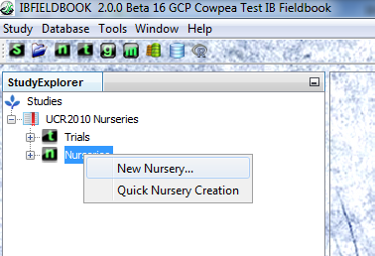

- The“Create New Nursery Wizard” will appear.

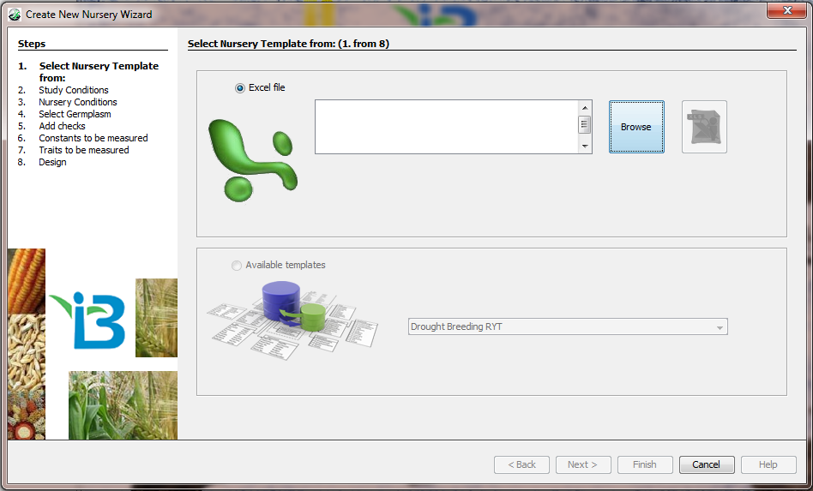

- Click the Browse button and navigate to your templates folder. For purposes of this tutorial, you can use a sample template found in the \ICIS5\Documents\Templates\IVIS that is automatically created during installation of IVIS program. Select “Cowpea – Nursery Template.xls” from the Templates folder and click ‘Open’. The template file name will appear in the box to the left of the browse button. Once the template file name appears you can view the selected template by clicking the Preview button found to the right of the Browse button.

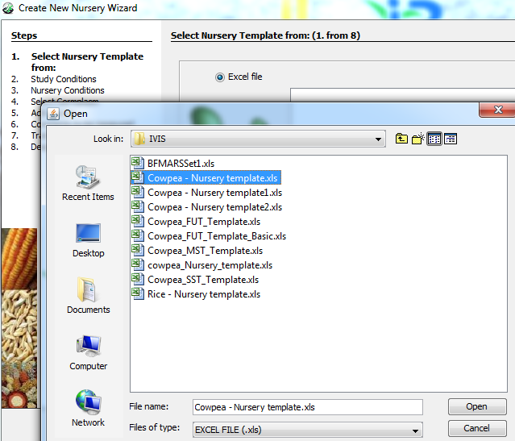

Note: The template specifies the nursery treatment and sampling structure and it offers a list of traits for observation. Trial and nursery templates have a special format and are created by researchers and data managers.

- Click Next. In the left hand column of the browser, Step No. 2 ‘Study Conditions’ will be in bold.

Note: Study conditions specify relevant conditions for the whole study – e.g. the principal investigator (as in the example shown) or whether all trial instances were irrigated or not.

- The list of study conditions is specified by the nursery template. Enter the values for those conditions in the Value column by typing values or selecting from pick lists when available. Values for Breeding Method and Breeding Method ID are for the breeding method to be applied to the nursery when it is grown.

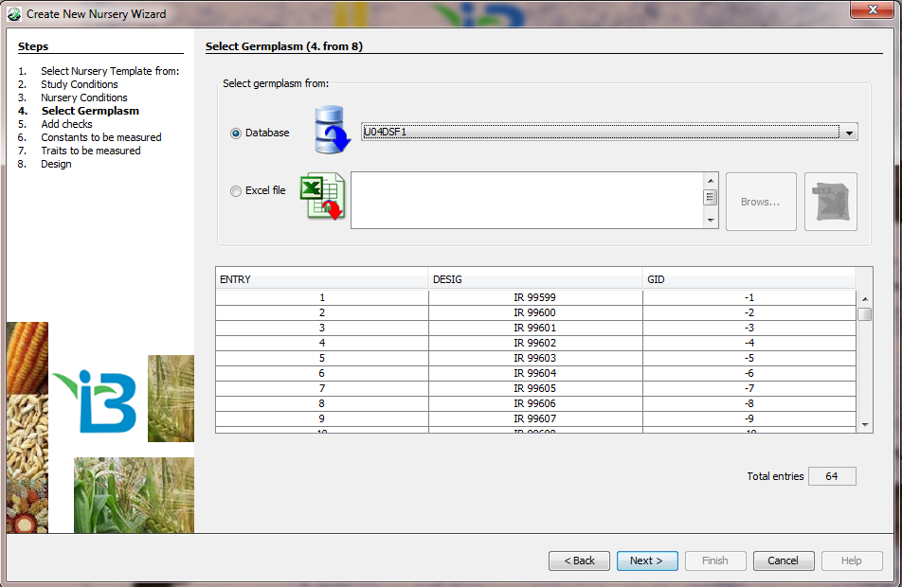

- Click Next. The Germplasm selection page will appear. Step 4 ‘Select Germplasm’ will appear in bold in the left hand side.

Specify the nursery list. This can be from a specially formatted excel file, or from the database connected to the Fieldbook.

In this exercise, we will get the nursery list from the database. Go to the last entry of the list box and select “UCR2010F1”

- Click Next. The Add Checks page will appear. “Step 5. Add Checks” will appear in bold on the left-hand side. In this example, we will not add checks.

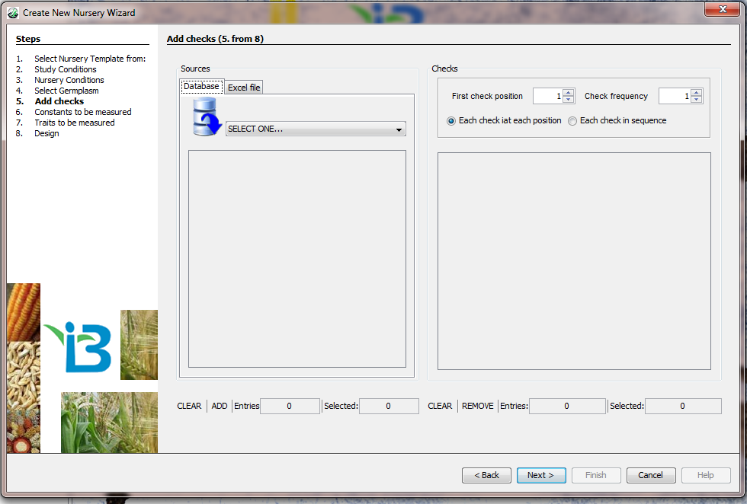

- Click Next. The ‘Traits to be Measured” page will appear and ‘Step 7. Traits to be measured” will be in bold on the left-hand side.

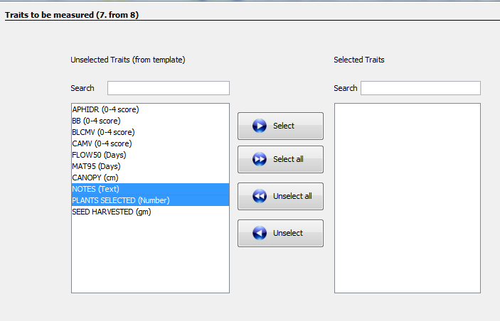

These are automatically entered from the nursery template into the Unselected Traits field box. Individual trait to be observed for each nursery can be selected by dragging desired trait from the Unselected Traits set into the Selected Traits set or – alternatively – selecting each and clicking the “Select” button. All can be selected by simply clicking the “Select All” button. Traits can be unselected in the same manner. Fields will be made available in the Nursery Book for the associated observations for each entry.

In this example, highlight NOTES and PLANTS SELECTED and click Select.

- Click Next. The ‘Design’ page will appear and ‘Step 8. Design” will be in bold on the left hand side.

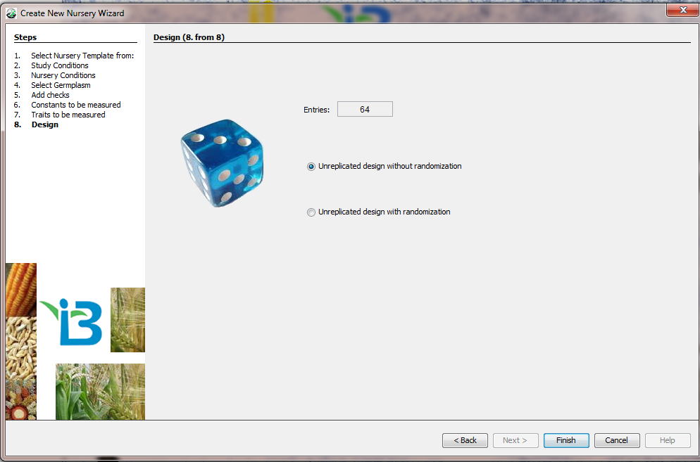

- In this example, tag the “Unreplicated design without randomization”

- Click Finish. The Trial Editor page will appear.

- Information from each step in the nursery wizard is contained on a separate tab of the Nursery Editor. The editor allows the user to view and edit all elements of the nursery book.

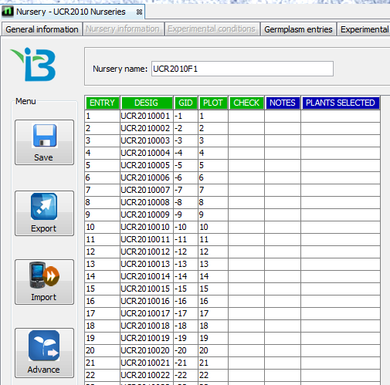

- Go to the Measurements tab. This contains the plot level data table. Enter a name in the text box beside Nursery name. In this example, enter “UCR2010F1” Then click the Save button on the left-hand side of the spread sheet.

- To export the nursery book for data collection, press the Export button located on the left-hand side of the spread sheet. The Export Wizard will appear with the Destination page opening first. This page allows you to choose the format in which the data table will be exported: a file for the Fieldlog or Fieldroid, a CSV file for analysis with R, or an Excel Workbook.

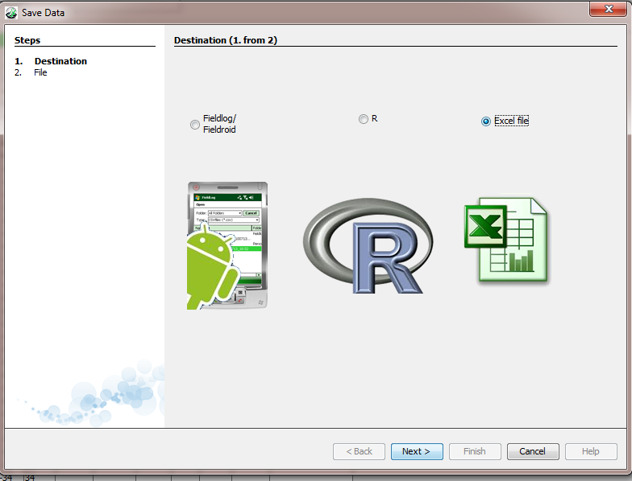

- For this exercise, choose the third option, Excel file. Press Next and click Browse to go to the folder where you want to store the Excel file. Type the name of the file and click Save.

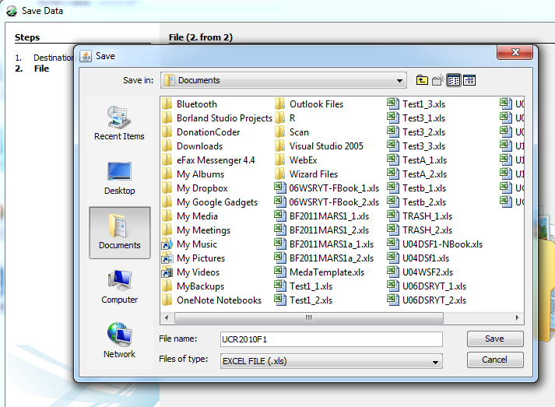

- A message box will appear asking if you want to open the file.
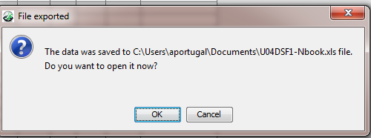

Click OK if you want to open it, otherwise click Cancel. In this example, click OK to see the nursery book.

- You can either print or transfer the nursery book to a handheld device for data recording.

Table of ICIS Breeding Methods for Self Fertilizing Crops

METHN | MTYPE | MGRP | MCODE | MNAME | MDESC
Methods for storing historical pedigrees with incomplete information
1 | GEN | S | UGM | UNKNOWN GENERATIVE METHOD SF | Unknown generative method for storing historic pedigrees for self fertilizing species.
4 | GEN | S | BDU | F1 BACKCROSS, CYTOPLASM UNKNOWN SF | Cross of F1 to recurrent parent when the direction of the cross is unknown for storing historic pedigrees for self fertilizing species.
6 | GEN | S | BRU | F2 BACKCROSS, CYTOPLASM UNKNOWN SF | Cross of F2 to recurrent parent when the direction of the cross is unknown for storing historic pedigrees for self fertilizing species.
8 | GEN | G | CCU | CROSS, CYTOPLASM UNKNOWN | Cross between two plants, unknown which is female
31 | DER | S | UDM | UNKNOWN DERIVATIVE METHOD SF | Unknown derivative method in self-fertilizing species: for storing historic pedigrees
Generic Maintenance Methods
60 | MAN | G | IDN | PLANT IDENTIFICATION | Identifying and naming a plant or population.
61 | MAN | G | NSI | SEED INCREASE | Increase seed of a cultivar, line, population or accession.
62 | MAN | G | ISE | IMPORT | Import seed, clones or tissue culture of a cultivar, line, population or accession.
63 | MAN | G | ESE | EXPORT | Export seed, clones or tissue culture of a cultivar, line, population or accession. This method is not required.
64 | MAN | G | SSN | STORE SEED NORMAL | Store seed of a cultivar, line, population or accession in normal method: drift not expected. It is unlikely that this method is needed.
65 | MAN | G | SSM | STORE SEED MEDIUM TERM | Store seed of a cultivar, line, population or accession in medium term storage. Some genetic drift is expected. Storage is between 0-4^{O}C and low RH.
66 | MAN | G | SSL | STORE SEED LONG TERM | Store seed of a cultivar, line, population or accession. Genetic drift is expected. Storage is about -18^{O}C.
Generative Methods for Inbreeding Crops
101 | GEN | S | C2W | SINGLE CROSS  (may consider adding TEST CROSS, for hybrid rice breeding) | Cross between two single plants. If both parents are fixed (pure) inbred lines there will be no segregation for gametes or genotypes and theoretically all crosses will result in the same genetic outcome. In plant breeding practice the theoretical situation is rarely encountered. In spite of this the usual practice is to bulk the seed. However, in genetical studies it is often necessary to keep individual seed separate. When this is done a separate entry in the germplasm table is required for each entity (seed) kept separate.
102 | GEN | S | C3W | THREE-WAY CROSS | Cross between two plants, one an inbred line and one a single cross (usually an F1) and thus segregating for gametes. In the theoretical case, rarely achieved, the inbred line would be fixed and the F1 a cross between fixed lines. The segregation for gametes results in different genetic outcomes among different progeny, hence a number of crosses using the same F1 is usually made. Since different F1 s are genetically the same (theoretically) only one F1 is required. In plant breeding programs the different crosses are usually bulked. Again, if individual seeds are kept separate a different entry is required in the germplasm table.
103 | GEN | S | CDB | DOUBLE CROSS | Cross between two single crosses (usually two F1s) and hence both segregating for gametes. The comments for method 102 apply but now for both female and male sides of the cross. Again, if individual seeds are kept separate a different entry is required in the germplasm table.
104 | GEN | S | CFT | FEMALE COMPLEX TOP CROSS | Cross between a female inbred line and a three-way or more complex cross among inbred lines, thus the male is segregating for genotypes as well as gametes. A consequence of the genotypic segregation is that selection can, and is usually made among the plants used as male parents. A consequence is that there will be genetic variation both within and between each cross. Usually all seed is bulked and selection practiced among the progeny. A different entry is required in the germplasm table for each entity kept separate.
105 | GEN | S | CMT | MALE COMPLEX TOP CROSS | Cross between a male inbred line and a three-way or more complex cross among inbred lines, thus the female is segregating for genotypes as well as gametes. The same genetic consequences occur as for the previous complex cross except for the cytoplasm. This method is rarely if ever encountered in practice because of the difficulty of using many females. A different entry is required in the germplasm table for each entity kept separate.
106 | GEN | S | CCX | COMPLEX CROSS | Cross between two three-way or more complex crosses among pure lines, thus both sides are segregating for both gametes and genotypes. A different entry is required in the germplasm table for each entity kept separate.
107 | GEN | S | BC | BACKCROSS | Backcross to recover a specific gene. The coding in the genealogical table records which parent was used as the female in each cycle. A different entry is required in the germplasm table for each entity kept separate.
108 | GEN | S | BCR | BACKCROSS RECESSIVE | Backcross to recover a recessive gene. As this requires a self fertilization (derivative method) in the process some ICIS administrators may distinguish this as a separate method. A different entry is required in the germplasm table for each entity kept separate.
109 | GEN | S | CIS | INTERSPECIFIC CROSS | Cross between two species. The problem with making this a separate method is that the species cross could be made by any of the previous (101-108) or following (110-113) methods.
110 | GEN | S | CSP | SELECTED POLLEN CROSS SF | A bulk of pollen from a selected set of males used to pollinate a female inbred line.
111 | GEN | S | CRP | RANDOM POLLEN CROSS SF | A random bulk of pollen from some population used to pollinate a female pure line. Male is then a population and will be recorded as a single entity.
112 | GEN | S | CGO | OPEN POLLENATED SF | Open pollination in a self- fertilized species
151 | GEN | S | MUN | NATURAL VARIANT SF | A recognized naturally occurring variant in a self- fertilizing population.
152 | GEN | S | MIP | INDUCED MUTATION POPULATION SF | A population derived from inducing mutation in a inbred line.
153 | GEN | S | SCL | SOMACLONE SF | Variation induced through tissue culture of a inbred line.
154 | GEN | S | ALP | ALLOPOLYPLOID SF | Polyploid formed by doubling the chromosomes of a cross between two or more species. Wheat is an allopolyploid as it contains genomes from three different species.
155 | GEN | S | AUP | AUTOPOLYPLOID SF | Polyploid formed by doubling the chromosome number of a species. Lucerne (alfalfa) is an autopolyploid with 4 sets of the same genome.
156 | GEN | S | HAP | HAPLOID SF | Individual with chromosome content of reduced gamete. Often formed by female progenitors crossed with a haploid inducer.
157 | GEN | S | TRN | TRANSGENIC NUCLEUS SF | Individual derived from genetic transformation of the nucleus in a self fertilizing species.
158 | GEN | S | TRC | TRANSGENIC CYTOPLASM SF | Individual derived from genetic transformation of a cytoplasm inclusion (e.g. chloroplast) in a self- fertilizing species.
Derivative Methods for Inbreeding Crops
201 | DER | S | MIL | INDUCED MUTATION LINE | A recognized mutation selected from an induced mutation in a line of a self-fertilized species.
202 | DER | S | DDH | DOUBLE HAPLOID LINE | Individual produced by doubling haploid individual usually by anther culture in a self- fertilized crop.
203 | DER | S | DPR | PURIFICATION | Selection of one or a few plants from an inbred line or pure line cultivar.
204 | DER | S | DRU | ROUGING SF | Eliminating off types from a inbred line or pure line cultivar.
205 | DER | S | DSP | SINGLE PLANT SELECTION SF | Derivation through selection of a single plant, inflorescence, fruit or seed from a self-fertilizing population.
206 | DER | S | DSB | SELECTED BULK SF | Derivation through bulking seed from a selected set of single plants from a self-fertilizing population.
207 | DER | S | DRB | RANDOM BULK SF | Derivation through bulking seed from a random selection of single plants from a self-fertilizing population.
208 | DER | S | DSD | SINGLE SEED DESCENT SF | Derived through the production of a single individual without selection from each individual in a segregating population.
209 | DER | S | DRS | CMS RESTORER SELECTION | Restorer Lines selected at the end of a program to back cross a gene which restores male fertility to lines carrying a Male Sterile Cytoplasm (CMS) to the male of a commercial hybrid.
210 | DER | S | DMS | CMS MAINTAIN ER SELECTION | Maintainer line selected at the end of a program to create the male fertile equivalent of the CMS female parent of a hybrid
251 | DER | S | ALP | LANDRACE POPULATION SF | Acquisition only.  A Landrace Accession of a self-fertilized species. This population will consist of a heterogenous mixture of homogenous genotypes.  This and the following eight methods should be reserved for the acquisition of these types of population to any program when they are first collected. When they are transferred from one collection (germplasm bank, working collection or plant improvement program) to another they should be entered under the IMPORT method.
252 | DER | S | ALL | LANDRACE LINE SF | Acquisition only.  When the accession derives from a single plant in the Landrace Population.
253 | DER | S | ALC | LANDRACE CULTIVAR SF | Acquisition only.  A Landrace Cultivar Accession of a self-fertilized species. Accession of a long term cultivar, not bred or maintained by modern breeding methods. This would usually be less heterogenous than a traditional landrace.
254 | DER | S | ACP | COLLECTION POPULATION SF | Acquisition only.  An accession of a population of a cultivated self -fertilizing species not from farmer’s fields.
255 | DER | S | ACL | COLLECTION LINE SF | Acquisition only.  When the accession derives from a single plant in a Collection Population.
256 | DER | S | AWP | COLLECTION WILD SPP POPULATION SF | Acquisition only.  An accession of a self-fertilizing species.
257 | DER | S | AWL | COLLECTION WILD SPP LINE SF | Acquisition only.  When the accession derives from a single plant from a wild collection.
258 | DER | S | ADP | COLLECTION WEEDY SPP POPULATION SF | Acquisition only.  An accession of a self-fertilizing species which is a weed (because of the result of a hybrid between the cultivated and a wild species of the crop).
259 | DER | S | ADL | COLLECTION WEEDY SPP LINE SF | Acquisition only.  When the accession derives from a single plant in a collection of weedy species.
Management Methods for Inbreeding Crops
301 | MAN | S | NSP | SEED INCREASE PLANT SF | Seed increase from a single plant in a self-fertilized species.
302 | MAN | S | NMX | SEED INCREASE MIXTURE SF | Seed increase from a number of selected plants in a self- fertilized species.
303 | MAN | S | NBK | SEED INCREASE BULK SF | Seed increase from an unselected bulk in a self-fertilizing species.
320 | MAN | S | VPL | PURE LINE FORMATION | Forming a pure line CV in a self-fertilizing species.
321 | MAN | S | VHY | HYBRID FORMATION SF | Forming a hybrid CV in a self-fertilizing crop.
322 | MAN | S | VML | MULTI-LINE FORMATION SF | Forming a multi-line CV in a self-fertilizing crop
323 | MAN | S | VBS | BREEDERS SEED SF | Producing Breeder’s Seed. Pure seed produced by breeder (usually some kept by breeder) in a self-fertilizing crop.
324 | MAN | S | VFS | FOUNDATION SEED SF | Producing Foundation Seed. Pure seed derived from Breeders seed (usually kept by seed producing organization) in a self-fertilizing crop.
325 | MAN | S | VCS | CERTIFIED SEED | Producing Certified Seed. Pure seed produced under supervision by Government Protocols.
326 | MAN | S | VCR | CULTIVAR RELEASE | Release a cultivar

